XGBoost Classifier
Suppose we want to predict whether a person is obese (binary classification) using his/her Gender and Cholesterol level. In specific, we have 10 people in the training set — 3 of them are obese, the remaining 7 people are not obese.
💦 Friendly reminder — The process might seem to be tediously long, but the concept is actually simple and straight-forward!

1. Assigns same initial predictions (0.5) to samples
As a start, we assign initial predictions to each sample. Since we haven’t trained any model or learned anything from the data, we can simply set 0.5 as initial prediction for every sample. Namely, a person has 50% chance being obese.
⚡ 0.5 is the default value in XGBoost module. We can change it to whatever value we like as long as it’s in the range [0, 1].

2. Calculate Pseudo-residual for each sample
Pseudo-residuals are nothing special but the intermediate error term that the predicted values are temporary/intermediate. Hence, pseudo-residual is calculated by (Actual value — Predicted value).
In this example, 3 people are obese (represented by 1), so their pseudo-residuals are (1–0.5) : 0.5. The remaining 7 people are not obese (represented by 0), so their pseudo-residuals are (0–0.5): -0.5.
⚡ The predicted values of all the samples are the same since it’s our FIRST tree. After the first iteration, the predicted values are likely to be different.

3. Build a decision tree based on Pseudo-residuals
Now, we can build our first tree. Like normal decision tree, we split on the attributes with the best quality. Unlike normal decision tree, the quality is NOT measured by mean squared error on pseudo-residuals, XGBoost has a unique method to choose attribute.
To be more specific, we calculate a Similarity score for each node. Then, the Gain of a node is the similarity score of its left child node + the similarity score of its right child node - the similarity score of itself. Finally, we select the split with highest gain.
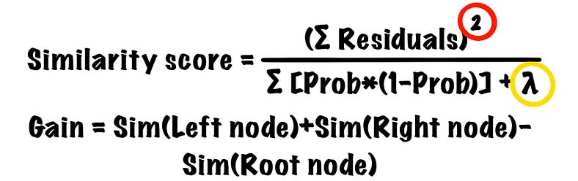
The similarity score formula of XGBoost is similar to the formula used to calculate output leaf value in gradient boosting. However, we take the square of the summation of residuals.
⚡ We sum up the residuals before we take the square. Thus, the positive residuals and negative residuals will be cancelled out!
Then, we have a lambda in the denominator, which is a regularization parameter. You might already know that boosting algorithms are prone to overfitting, and XGBoost is no exception. Therefore, we need to limit the model’s ability to learn. By adding lambda, both the similarity score and gain will be lower, which leads to our next step — Tree pruning.

4. Prune the tree — Both leaves and nodes
To reduce the issue of overfitting, we can set our own pruning thresholds. Let’s start with the node pruning. γ (gamma) in XGBoost is the minimum acceptable node gain. If a node has lower gain than γ, that node will be pruned and the tree will be shallower. Hence, if we set a high γ or add a large λ when calculating similarity scores, the tree will be more limited in depth.
Moreover, XGBoost can prune the leaves using Cover. We can think of cover as the minimum child node weight allowed. The formula of cover is simply the denominator of similarity score without λ— Σ [Prob * (1-Prob)]. If only 1 child node has higher weight than cover, we will still remove both leaves since the split is only legit when 2 leaves satisfy the cover restraint.
⚡ We prune the tree from bottom to top. If a lower node has higher gain than γ, we stop. Even if the top node has lower gain than γ, we don’t prune it.

5. Compute the output value of each node in log-odds
As a matter of fact, we use residuals of Probabilities to build a tree and the leaves. However, the predictions should be in Log-odds (inherits the concept of logistic regression). Hence, we need to transform the output value of each node in log-odds, and the most commonly-used formula goes like this.
⚡ The formula is almost exactly the same as in gradient boosting, except that we now have an additional regularization parameter — λ.

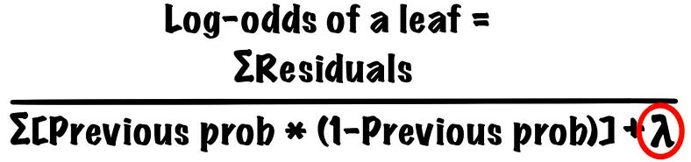
As before, the λ here reduces prediction’s sensitivity to isolated observations and reduce the chance of overfitting. Say the λ is 1 and we have a leaf containing 2 obese people and 1 non-obese person. The residual of obese person is 0.5; the residual of non-obese person is -0.5 (step2). The previous probabilities for everyone are 0.5 since we assign equal predictions in step1. Therefore, the output value of this leaf is (0.5 + 0.5 + (-0.5)) / [(0.5 * (1–0.5)) + (0.5 * (1–0.5)) + (0.5 * (1–0.5)) + 1], which is 0.286.
⚡ The previous probabilities for different samples should be different. They should only be the same in the First tree.

6. Updates the previous predicted probabilities
The output values we calculated in step5 is used to update predicted probabilities (step1). The formula goes like this.
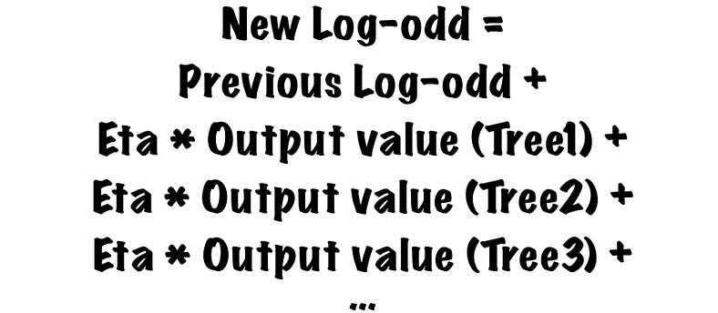
As in gradient boosting, we can assign a learning rate. Well, in XGBoost, the learning rate is called eta.
If the eta is high, the new tree will learn a lot from the previous tree, and the probability of overfitting will increase. Nevertheless, if the eta is low, the tree will improve in a slow manner, and we will need more trees to achieve high accuracy. Therefore, eta is also a regularization parameter that is used to prevent the algorithm from overfitting.
Before we plug in the formula, we have one more thing to do. In step1, we predicted that every person has 50% chance being obese, but that’s not the log-odd. We need to convert the predicted probability to log-odds, and it can be calculated by log(p/(1-p)).
In specific, the log-odd of probability 0.5 is log(0.5/(1–0.5)), which is 0. Therefore, given eta 0.3, the new log-odd of a person who belongs to the example leaf in step5 will be 0 (previous log-odd) + 0.3 * 0.286(output value of tree 1), which is 0.086.
⚡ We take a baby step at a time by setting a low eta. Even if the direction of change is not right now (i.e., an obese people has a lower log-odds of being obese), we will be able to correct this as the number of iteration increases.

7. Repeat Step2 to Step6
Now we have a new set of log-odds, we need to convert them back to probabilities before building the second tree, and we can use this formula.

Afterwards, we repeat step2 to step6 until the required number of trees are built or the residuals are small (the predicted values are super close to the actual values).
Before we move on, how does XGBoost make classification exactly?
First, we use the formula in step6 to calculate a log-odd for new sample. Then, we convert the log-odd back to probability using the formula in step7 and compare this probability with our threshold!
If the log-odd of a person is 0.6, the predicted probability of that person being obese is 0646. Given the threshold 0.6, that person will be predicted as “Obese” since 0.646 is higher than 0.6.
In fact, gradient boosting and XGBoost has a lot in common, only that XGBoost is more flexible and more efficient.
Now we’ve learned the workflow of XGBoost, and we can use xgboost in Python. Furthermore, there are a LOT of parameters that can be tuned (We’ll only talk about a few of them).
- max_depth (default — 6): The maximum depth of a tree.
- n_estimators (default — 100): Number of trees in the XGBoost, which is 100 by default.
- eta (default — 0.3): Learning rate; determines the shrinkage of the contribution of a tree at each boosting iteration. When the learning rate is high, XGBoost tends to overfit the data; when the learning rate is low, we need more iterations to increase accuracy. Thus, n_estimators and learning_rate can be viewed as a trade-off.
- gamma (default — 0): Minimum gain required to split a node.
- reg_lambda (default — 0): Regularization parameter used to reduces prediction’s sensitivity to isolated observations.
⚡ xgboost is NOT in sklearn library, it is an independent library. You need to install the library first before importing it.
# Install
!pip install xgboost# Import
import xgboost as xgb

